

TWT2231: WEB TECHNIQUES AND APPLICATIONS

Individual Assignment

**Title: An Application Development for COVID-19 Epidemic**

Student Name: Cheong Ji Xiang

Student ID: 1201300548

Course: ST

Contents

1. Introduction.
2. Objectives
3. Scope of the assignment
4. Source code
5. Sample interface screen
6. Sample input /output screens
7. Conclusion

Introduction

In 2019, A new flu sweeps the world and threatens the lives of many. The name of the flu called **Coronavirus disease 2019** (COVID-19). COVID-19 spreads when people breathe air contaminated with virus-laden droplets and small airborne particles. It is difficult to completely wipe out COVID-19 in a short period of time. So in this era, it is very important to protect ourselves and protect others by wearing a mask when going to crowded place and keep ourselves clean all the time also. But, it is hard to complete isolation of human-to-human communication, because we need to live, need work for life, need food to eat, so we need transaction to meet demand.

In Malaysia, citizens also suffering from the COVID-19 global epidemic both monetarily and psychologically since the virus became out of control in Malaysia. Now, the government and Malaysian citizens were becoming increasingly concerned about the situation of COVID-19 in Malaysia. But, there was not much application in Malaysia for tracking COVID-19 status. Therefore, this assignment going to introduce a application that can easily display and track the status of COVID-19 cases in Malaysia’s states

This application is called Track COVID-19 (TC19), it provided total of 13 [states](https://en.wikipedia.org/wiki/Federated_state" \o "Federated state) and 3 [federal territories](https://en.wikipedia.org/wiki/Federal_Territories_of_Malaysia" \o "Federal Territories of Malaysia) in Malaysia. User can get some basic information for example each cases of COVID-19 in Malaysia with this application. With this application, not just citizens in Malaysia, travelers that come to Malaysia can easily track the severity of the cases of COVID-19 in Malaysia. Although the information may not 100% helpful due to some forced work, user maybe cannot avoid to the crowded places, but everyone can also have some preparation to protect themselves and protect the other in the serious situation.

Objective

The objective of this assignment is provide a application that helps the user to track the COVID-19 cases is Malaysia’s states. In Malaysia, there is only a few application to track the COVID-19 so this application can help user have more choice and information to know the COVID-19 situation in Malaysia. The Aim is to help the citizen to protect themselves and ease the work of healthcare workers, when there have one more people can be more aware to the COVID-19 because of this application the time we back to before the epidemic will be more closer.

System Requirement

Potential user and specific requirement

The user of this application is all the person in Malaysia, and there is no any specific requirement to user that want to use this application.

Required hardware, software platform

Need a text editor or html editor to develop this application, ex.notepad, notepad++.

To run this application, will need to setup a web server and the computer language must contain, HTML5, CSS3, PHP, JavaScript, MySQL, and a database.

 FTP client to transfer HTML files and supporting images and graphics to web server

| **Component** | **Minimum** |
| --- | --- |
| Processor | 1.9 gigahertz (GHz) x86- or x64-bit dual core processor with SSE2 instruction set |
| Memory | 2-GB RAM |
| Display | Super VGA with a resolution of 1024 x 768 |
| ****Network requirements**** | |
| Bandwidth | greater than 50 KBps (400 kbps) |
| Latency | under 150 ms |

Scope of the assignment

The application is already done, it have many function that fulfill the objective. It can check the basic information of COVID-19 in Malaysia, can identify the user is admin or not and let the admin do the information edit, interface user friendly. But there is still have some part that is unable to be done.

**Problem Statement**

1. The interface design is messy
2. Do not have login system for normal user, so this application have only the function to check, cannot do comment or feedback.
3. Do not have login system so there is also cannot track the people who is vaccinated.
4. For the admin login , only have 1 set of login which is

username: admin123

password: 123456.

1. The bar chart show in each states main page are fix, we can only adjust the information them by doing re code.
2. Have only 3 type of cases status listed.

Contribution of the assignment

This project can provide a simple and clear information to the user in Malaysia and help the government unit to relieve pressure. And it can provide a new application to the user to have more choice to track the situation of COVID-19

Source Code

**Due to length problem this document only include 2 page code for sample**

**Interface**

|  |
| --- |
| <!DOCTYPE html>  <html>  <head>  <title>TC19</title>  <style>  .title h1 {  text-align: center;  font-size: 100px;  font-weight: 700;  color:black;  text-transform: uppercase;  border-bottom: double  }  .intro h1 {  text-align: center;  font-size: 30px;  color:black;  }  .intro h2 {  text-align: center;  font-size: 40px;  color:blue;  }  table {  font-family: arial, sans-serif;  border-collapse: collapse;  margin: 50px 50px ;  }  td, th{  border:none;  font-size: 30px;  text-align: middle;  padding: 8px;  }  .import h1 {  text-align: center;  font-size: 50px;  font-style: bold;  font-family: tahoma;  color:red;  border-top: 5px solid black;  border-bottom: 5px solid black;  border-left: 5px solid black;  border-right: 5px solid black;  }  .center {  margin-left: auto;  margin-right: auto;  }  </style>  </head>  <body>  <div class="title">  <h1>Welcome to Track COVID-19</h1>  </div>  <div class="intro">  <h2>NOTES: This is a website FOR MALAYSIA ONLY !!!</h2>  <h1>In this era, we will have to live with the COVID-19, in this situation we must protect ourself to protect others.  <br>This website will help you to track the COVID-19 cases in your area in MALAYSIA</h1>  </div>    <p style="text-align:center;"><img src="satu.jpg" alt="Satu Malaysia" align="middle" width="450" height="500"></p>    <table class="center", style="width:50%">  <tr>  <th>Where you want to Track ?</th>  <th>Question</th>  </tr>  <tr>  <td><a href="east.html">East Malaysia</td>  <td><a href="https://en.wikipedia.org/wiki/COVID-19">What is COVID-19?</td>  </tr>  <tr>  <td><a href="west.html">West Malaysia</td>  <td><a href="https://en.wikipedia.org/wiki/Malaysia">Where is MALAYSIA?</td>  </tr>    <caption align="bottom">  <div class="import">  <br><br><br><br><br><br><br>  <h1>Wash your hands frequently wear a mask when going out!!!  <br>Wish you all the best. Take care and stay safe</h1>  </caption>  </body>  </html> |

**Johor Main Page**

|  |
| --- |
| <!DOCTYPE html>  <html>  <head>  <title>Johor</title>  <style type=text/css>  .bold {  font-weight: bold;  font-size: 20px;  }    .other{  font-size: 20px;  }    table, th, td {  border: 3px solid black;  }    h1 {  font-size: 60px;  color:blue;  }    h2 {  font-size: 30px;  color:blue;  }  #myChart {  position: absolute;  left: 50%;  top: 5%;  }    #myChart1 {  position: absolute;  left: 50%;  top: 40%;  }    #myChart2 {  position: absolute;  left: 50%;  top: 75%;  }    </style>  <script src="https://cdnjs.cloudflare.com/ajax/libs/Chart.js/2.9.4/Chart.js"></script>  </head>  <body>  <?php  //connect to database  $cont = mysqli_connect('localhost', 'root', '');    //ii check  if(!$cont){  echo("error");  }    //select database  if(!(mysqli_select_db($cont, "malaysia"))){  echo("error2");  }    //select all  $query = "SELECT * FROM johor";    if(!($result = mysqli_query($cont, $query))){  echo("Failed to run command");  }  echo "<h1>The Status of Johor</h1>";  echo "<table>";  echo "<tr>  <td style='text-align:center' class=\"bold\">Date:</td>  <td style='text-align:center' class=\"bold\">Death Cases:</td>  <td style='text-align:center' class=\"bold\">Confirmed Cases:</td>  <td style='text-align:center' class=\"bold\">Hospital Admission:</td>  </tr>";  while ($row = mysqli_fetch_row($result)){    $row[3]=str_replace("<br>","\n",$row[3]);    echo "<tr>  <td style='text-align:center' class=\"other\">$row[0]</td>  <td style='text-align:center' class=\"other\">$row[1]</td>  <td style='text-align:center' class=\"other\">$row[2]</td>  <td style='text-align:center' class=\"other\">$row[3]</td>  </tr>";    }  echo "</table>";  mysqli_close($cont);  ?>    <a href="admin.html"><h2>Edit the Data</h2></a>  <a href="..\index.html"><h2>Back to Main Page</h2></a>    <canvas id="myChart" style="width:100%;max-width:600px"></canvas>  <canvas id="myChart1" style="width:100%;max-width:600px"></canvas>  <canvas id="myChart2" style="width:100%;max-width:600px"></canvas>  <script>  var xValues = ["2022-03-16", "2022-03-17", "2022-03-18", "2022-03-19", "2022-03-20", "2022-03-21", "2022-03-22"];  var yValues = [11, 10, 14, 11, 10, 2, 0];  var barColors = "red";  new Chart("myChart", {  type: "bar",  data: {  labels: xValues,  datasets: [{  backgroundColor: barColors,  data: yValues  }]},  options: {  legend: {display: false},  title: {display: true,  text: "Death Cases in Johor:"  }}});  var xValues = ["2022-03-16", "2022-03-17", "2022-03-18", "2022-03-19", "2022-03-20", "2022-03-21", "2022-03-22"];  var yValues = [2577, 1990, 1624, 1286, 1441, 1088, 927];  var barColors = "blue";  new Chart("myChart1", {  type: "bar",  data: {  labels: xValues,  datasets: [{  backgroundColor: barColors,  data: yValues  }]},  options: {  legend: {display: false},  title: {display: true,  text: "Confirmed Cases in Johor:"  }}});  var xValues = ["2022-03-16", "2022-03-17", "2022-03-18", "2022-03-19", "2022-03-20", "2022-03-21", "2022-03-22"];  var yValues = [298, 313, 317, 249, 255, 297, 270];  var barColors = "green";  new Chart("myChart2", {  type: "bar",  data: {  labels: xValues,  datasets: [{  backgroundColor: barColors,  data: yValues  }]},  options: {  legend: {display: false},  title: {display: true,  text: "Hospital Admission in Johor:"  }}});  </script>  </body>  </html> |

Sample interface screen

**Interface**

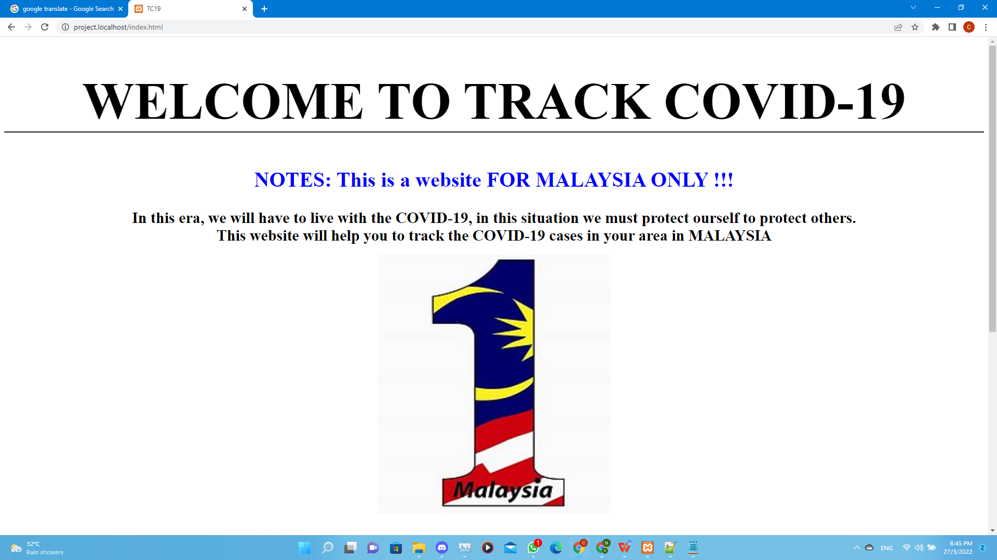

**Choose a status to have the COVID-19 information**

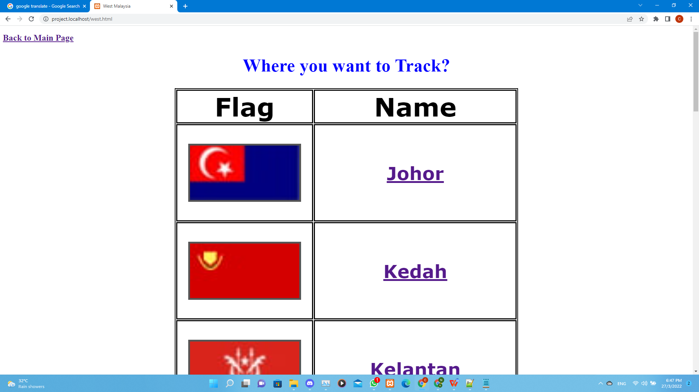

**Johor’s Status**

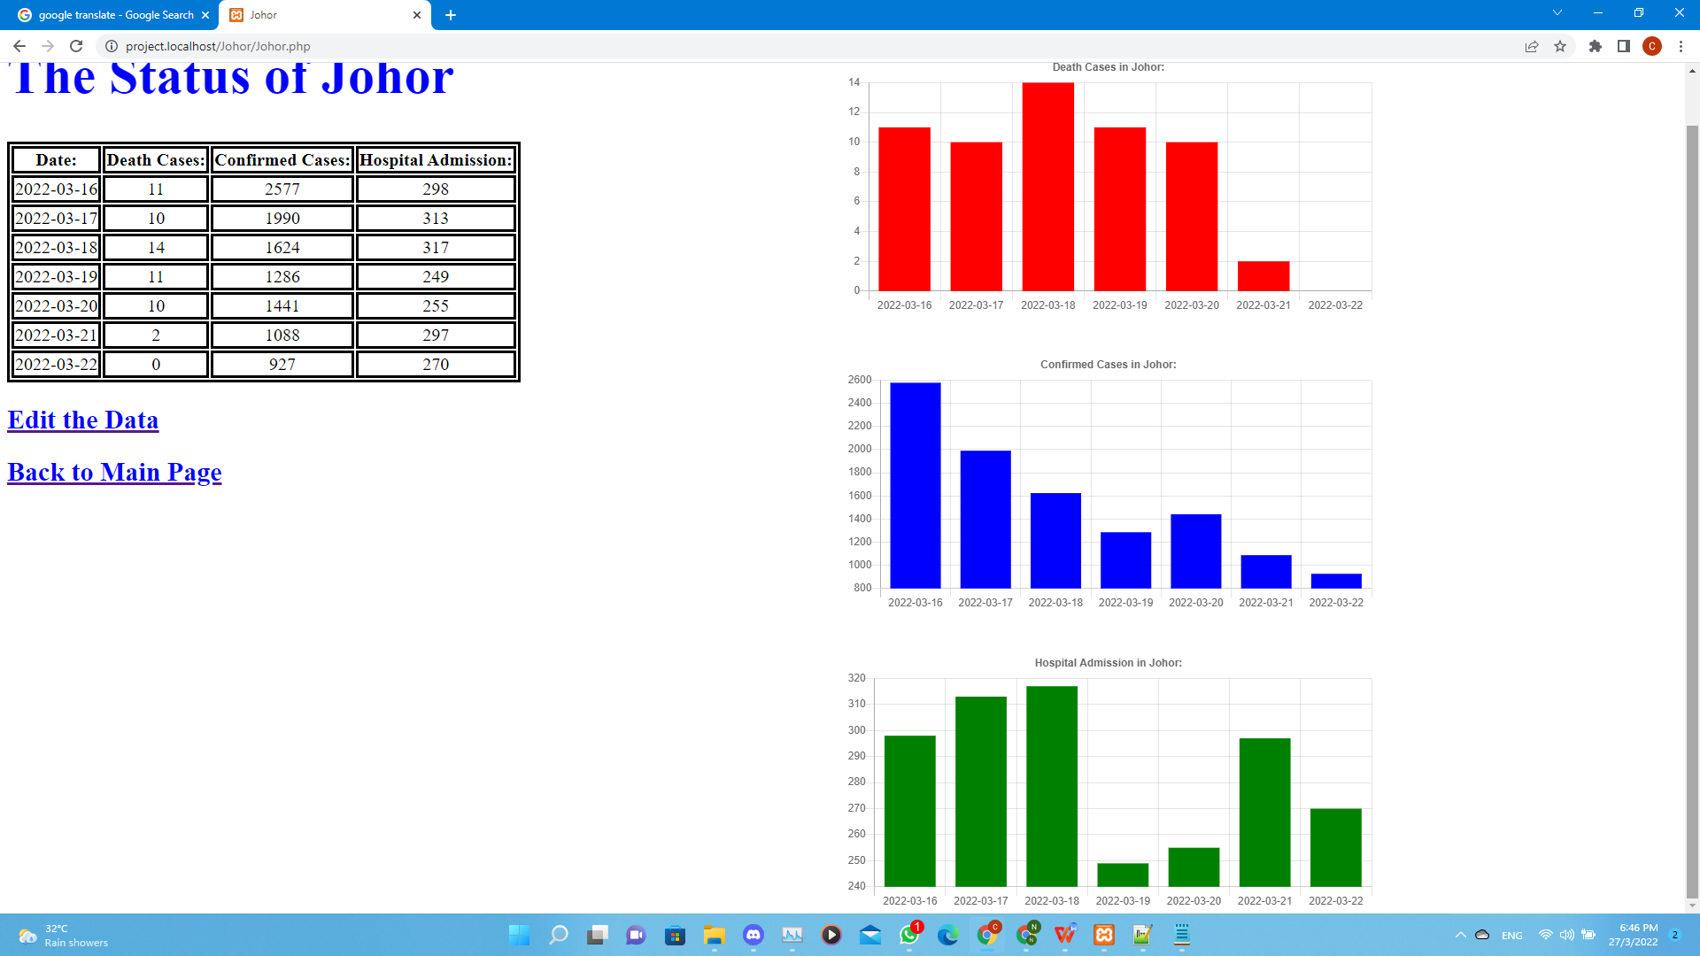

**Kedah’s Status**

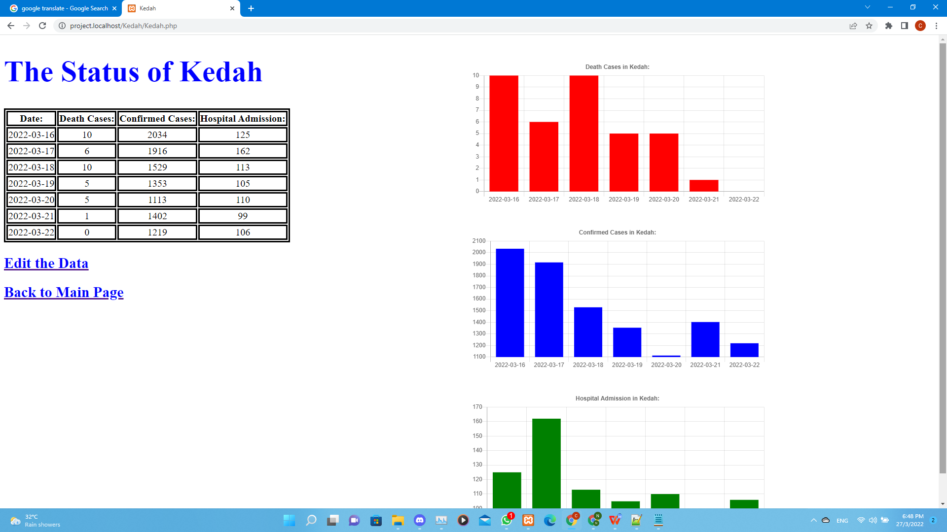

Sample input /output screens

**The status of Kedah**

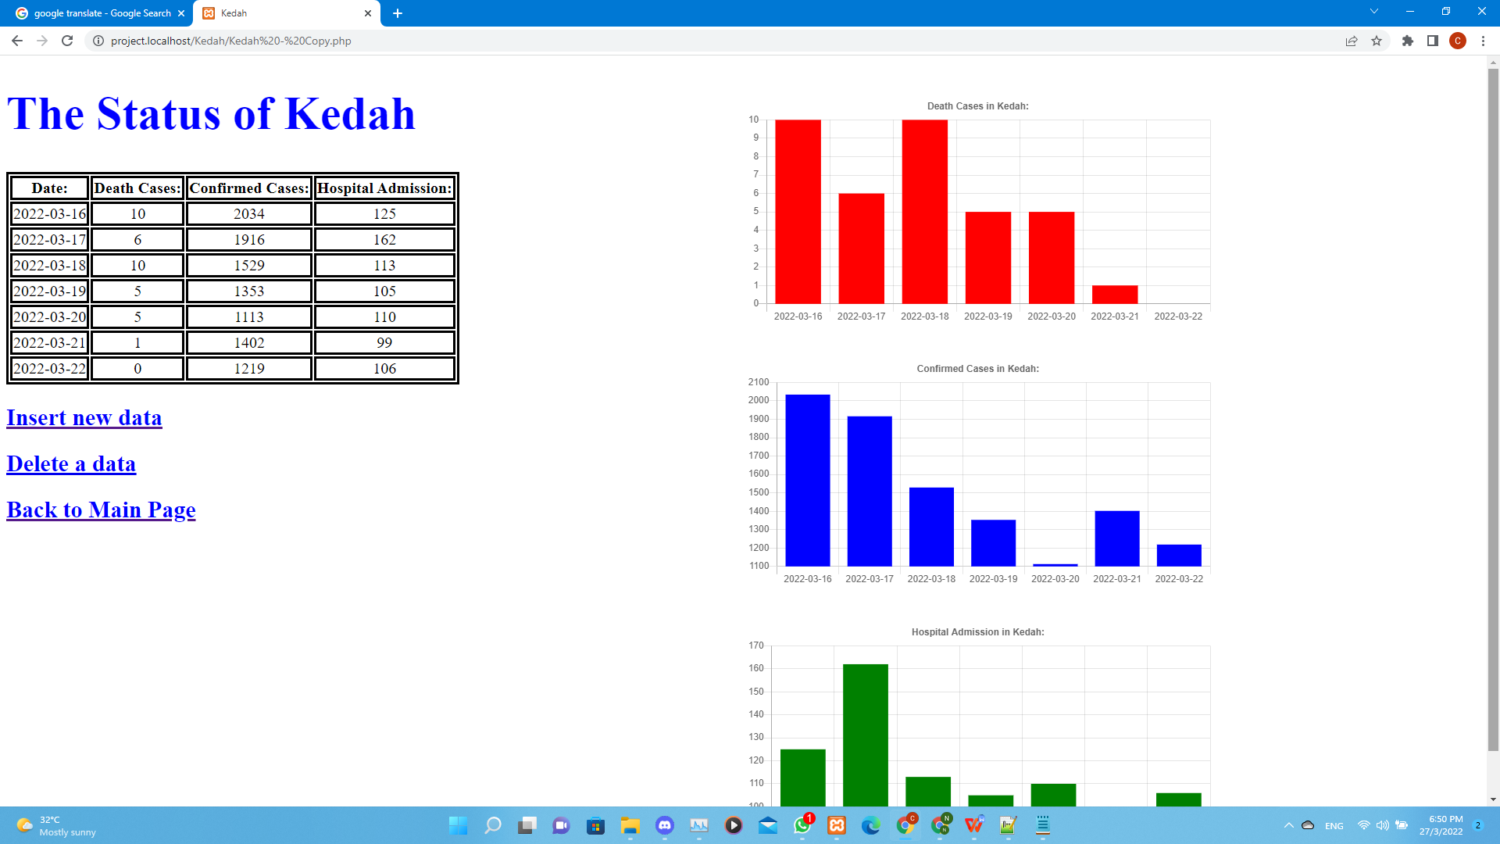

**Insert a new data which the date is 25/03/2022**

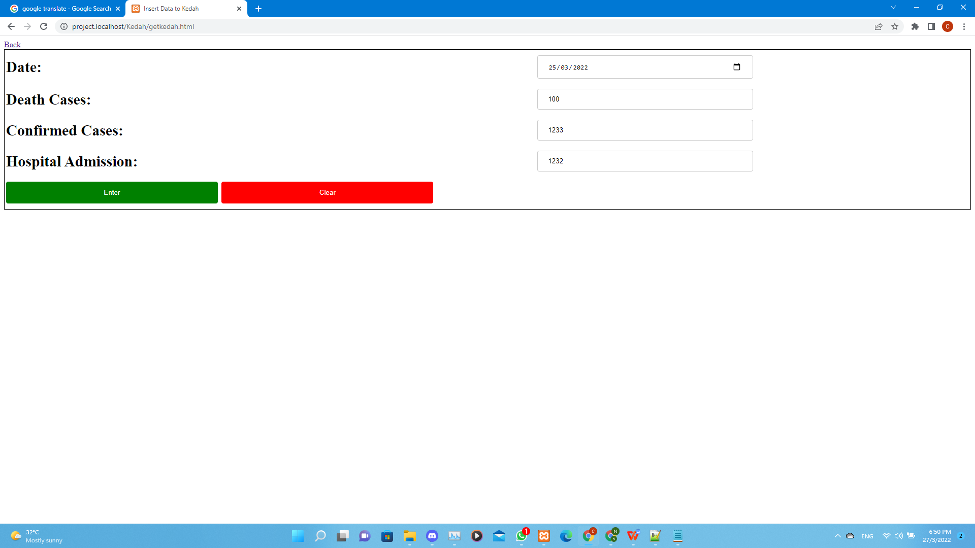

**The new status of Kedah**

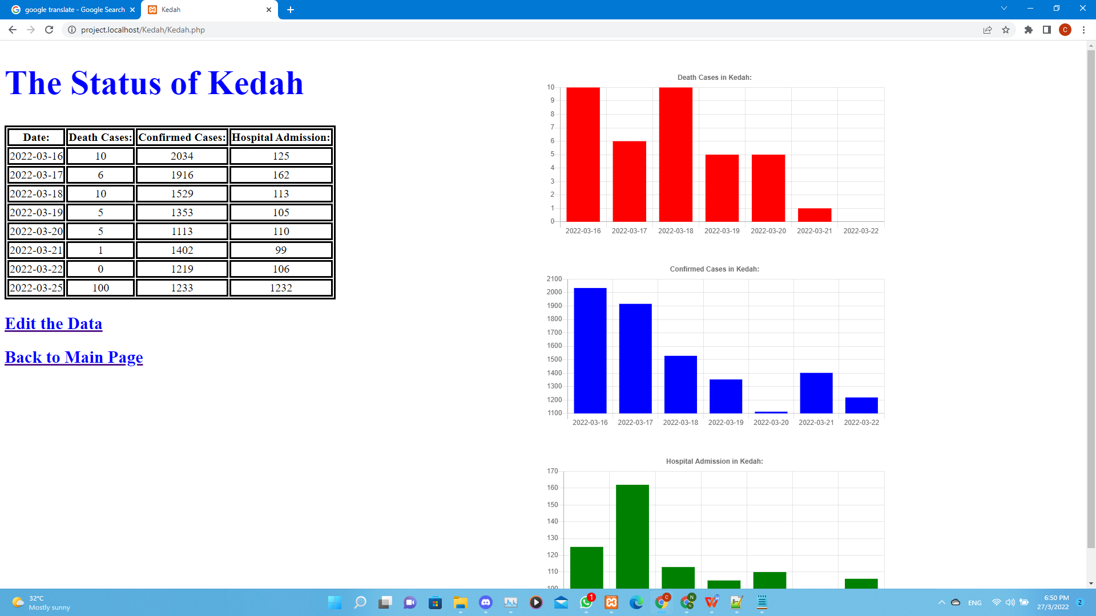

**Delete the new status**

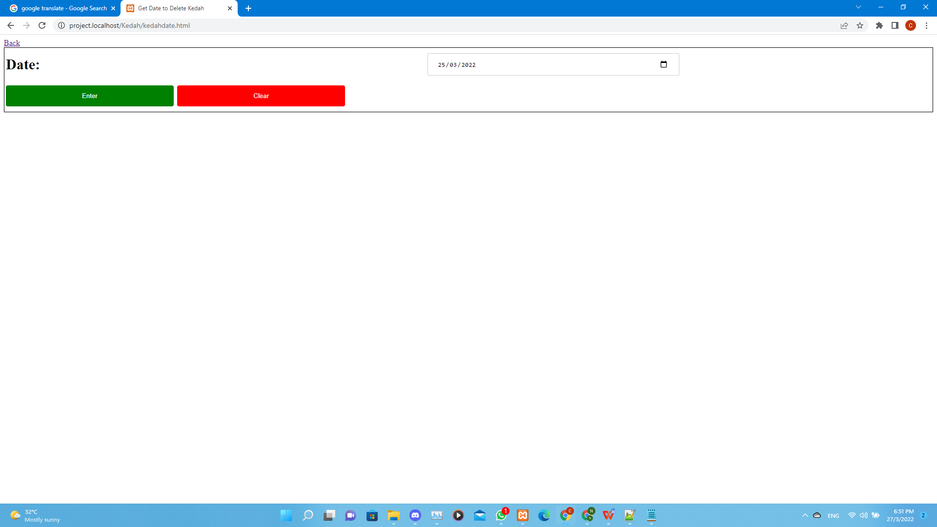

**After delete**

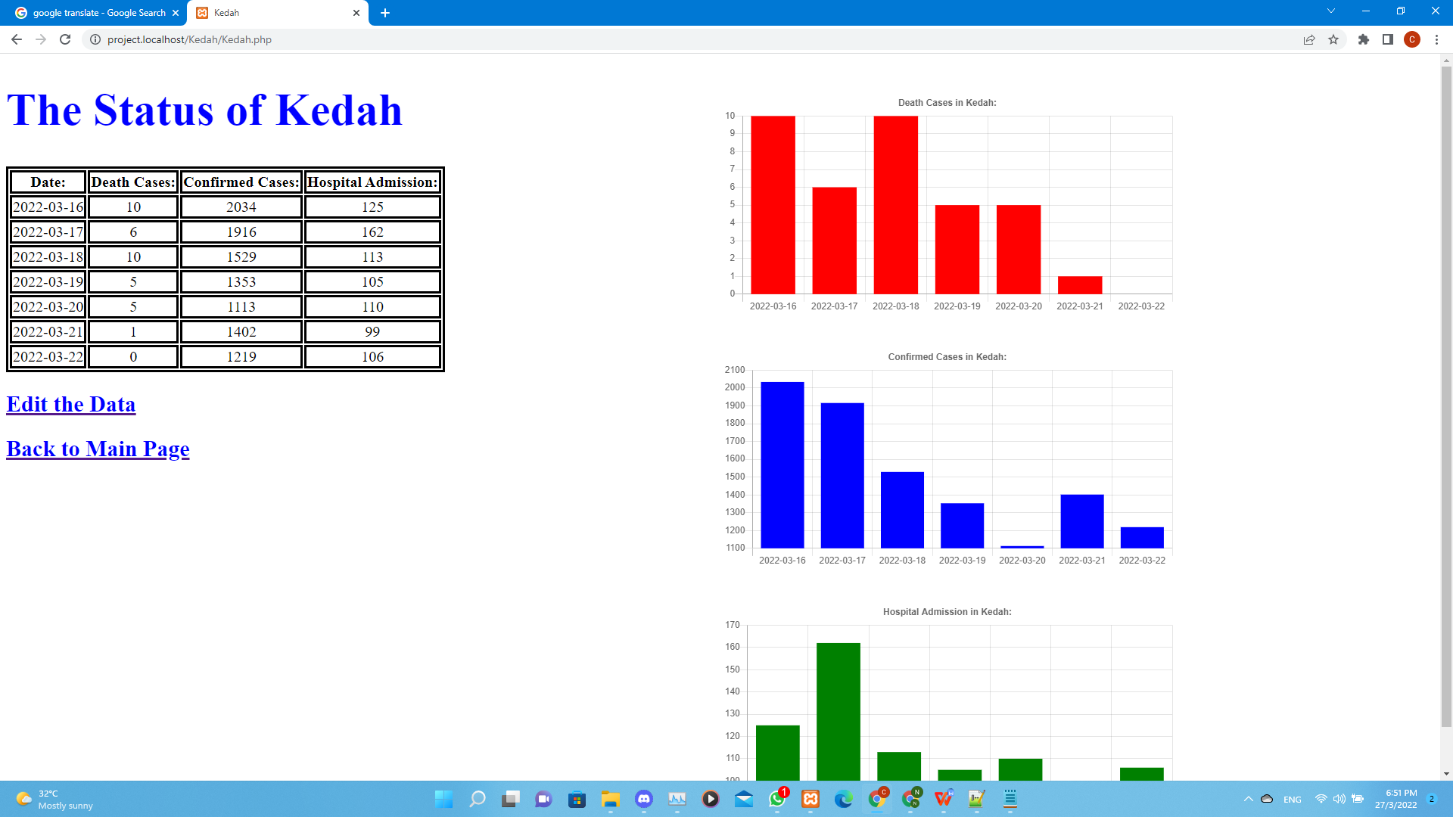

Conclusion

In this application, we can track the COVID-19 situation easily, but this application are not provide the safe place for the user to travel, even the cases in a place is low or even zero, it is still important to make yourself clean and wear mask when going out in this era. There is no place that is 100% safe, the only way to prevent the flu to catch you is protect yourself.

This main function of this application, is help to know the situation of the COVID-19 in Malaysia, any other uses may not be the purpose of this application, there is no an application can help you to setup your protection. Everyone needs to be aware of COVID-19 in this era, if not another another wave of flu intrusions would be here in short.

**“WEAR YOUR MASK WHENEVER YOU GO OUT. WASH YOUR HAND FREQUENTLY. PROTECT YOURSELF AND PROTECT THE OTHERS. TAKE CARE AND STAY SAFE.”**

This will be the main idea this project want to spread out.

Reference

<https://en.wikipedia.org/wiki/COVID-19>

https://en.wikipedia.org/wiki/Malaysia

<https://docs.microsoft.com/en-us/power-platform/admin/web-application-requirements>

https://cdnjs.cloudflare.com/ajax/libs/Chart.js/2.9.4/Chart.js